Practical-14
Admin Dashboard with Role-Based Access Control, Dynamic Menu, and Audit Log
Theory
1. Are dashboard values loaded dynamically from the database?
Answer: Yes. The administrator dashboard displayed 5 user accounts, 41 student records, 23 events and 7 registrations. A separate MySQL COUNT query returned exactly the same values. Recent registrations and a monthly registration chart were also displayed.
2. Is access restricted to admin users?
Answer: Yes. An incognito visit to admin.php redirected to login.php?status=login_required. A signed-in student trying to access the same admin dashboard received HTTP 403 Access Denied.
3. Are role-based menus working?
Answer: Yes. The administrator menu showed Admin Dashboard, Manage Students, AJAX Events and Events. The student account displayed My Dashboard, Events, Timetable and Attendance without administrator-only links.
4. Are important admin actions recorded in audit_logs?
Answer: Yes. The audit_logs table was initially empty. After an administrator deactivated the test student account, an account_deactivated record was saved for user p10_student01. The account was subsequently reactivated, but the activation audit entry was not independently photographed.
Result:
Practical 14 was implemented and tested in StudentHub using PHP, MySQL and role-based sessions. Database-backed totals, recent registrations, a monthly chart, login-required protection, student role restrictions, dynamic navigation, account deactivation and reactivation were demonstrated. A deactivation entry was verified in audit_logs.
Evidence of Work (Screenshots)
The following original screenshots show the SQL upgrade, admin dashboard, database queries, role restrictions, dynamic student menu, audit table and account-status changes. Only the demonstrated results are reported.

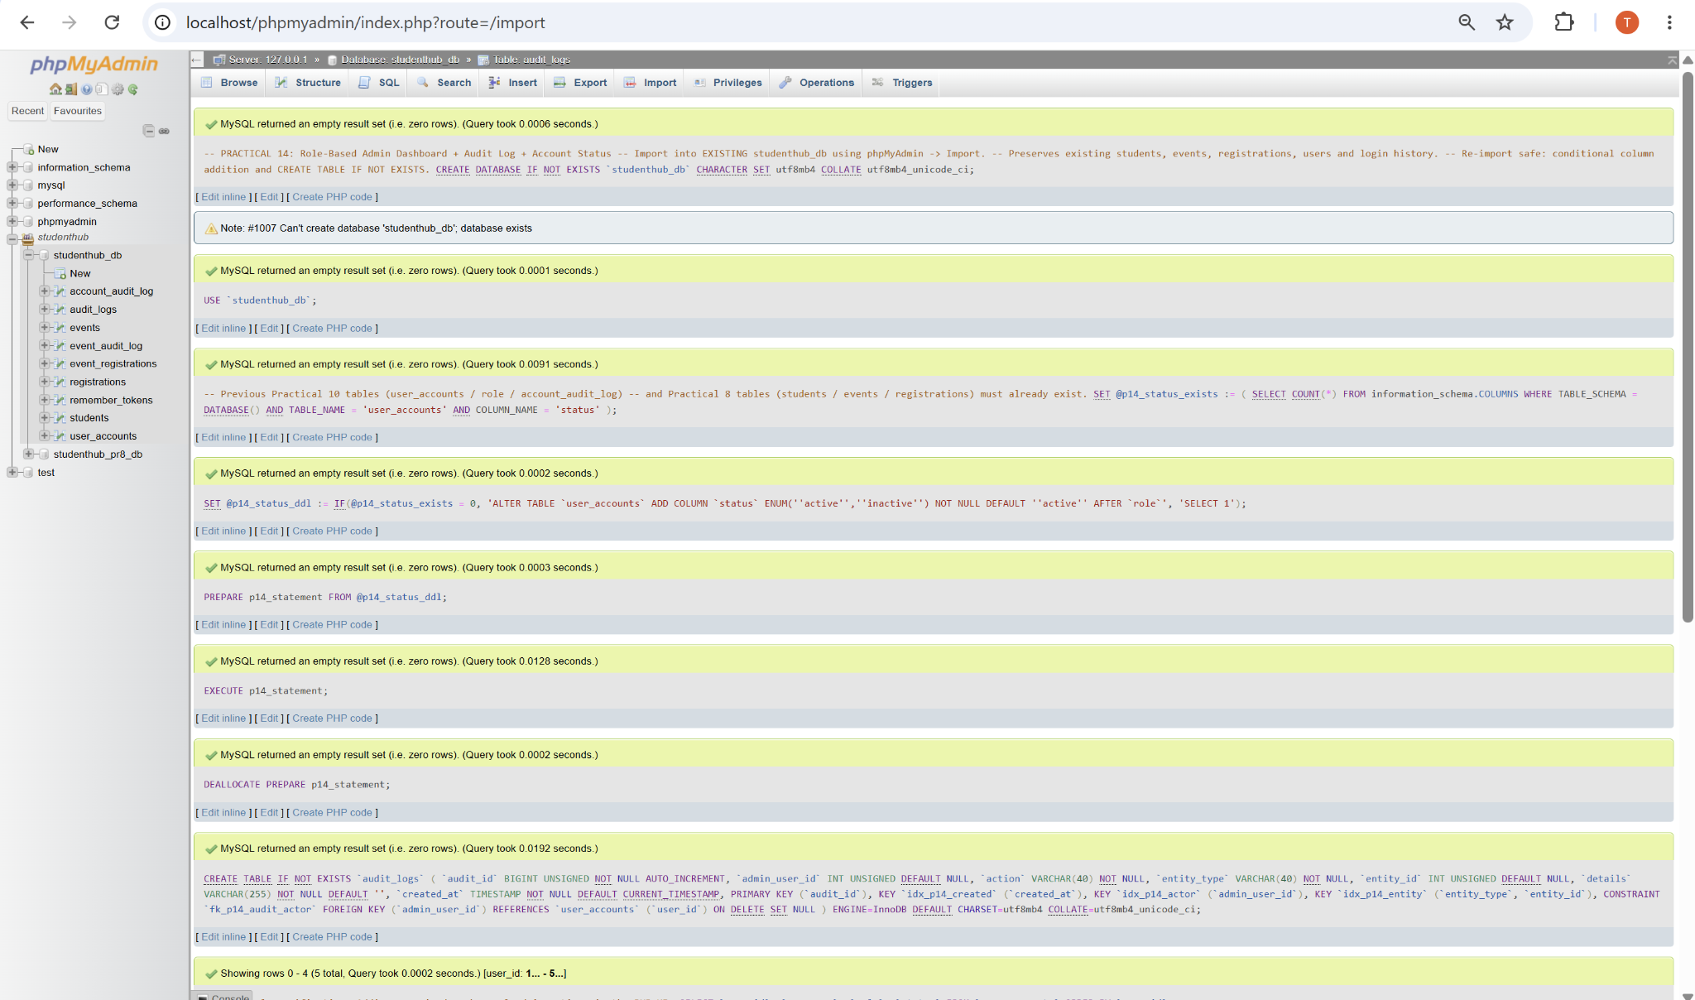
Figure 1: Practical 14 SQL Upgrade and audit_logs Table Setup
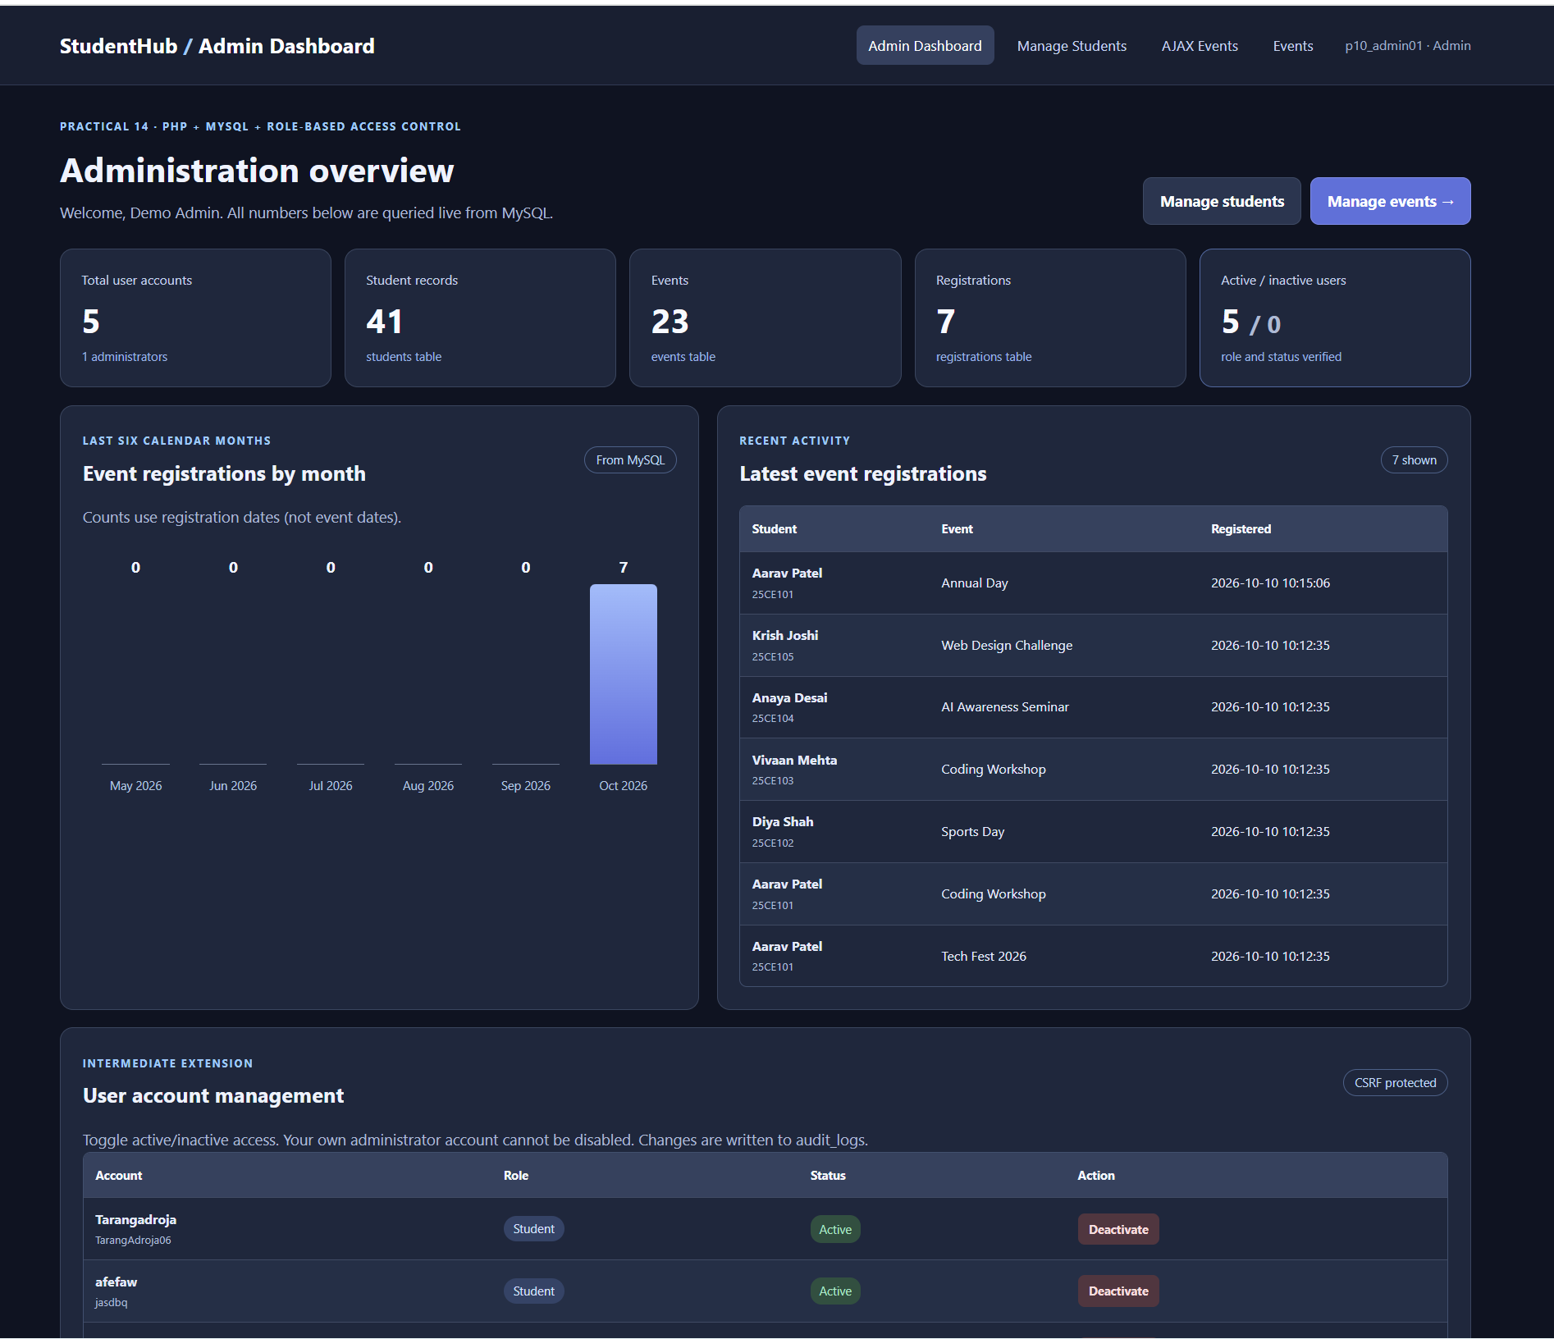
Figure 2: Admin Dashboard with Live Counts and Monthly Registrations

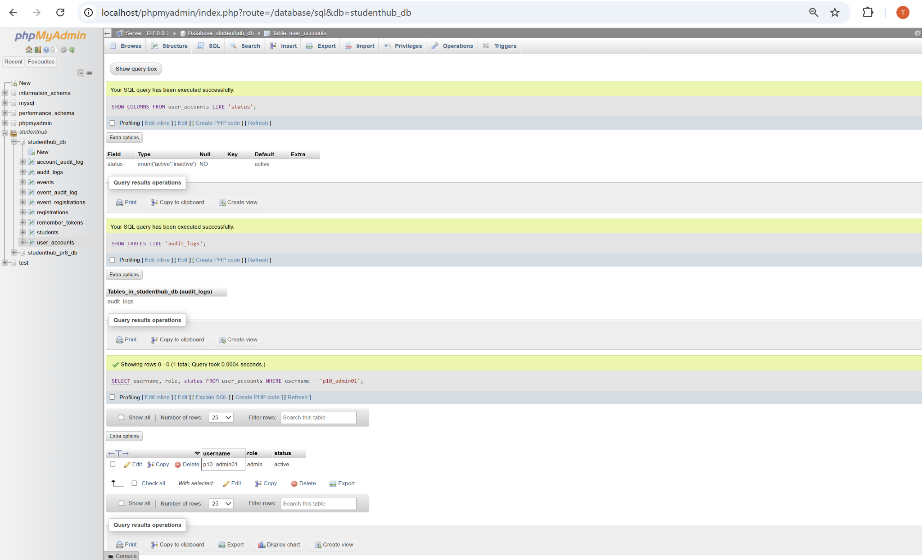
Figure 3: Admin Role, Status Column and Audit Table Verified in MySQL
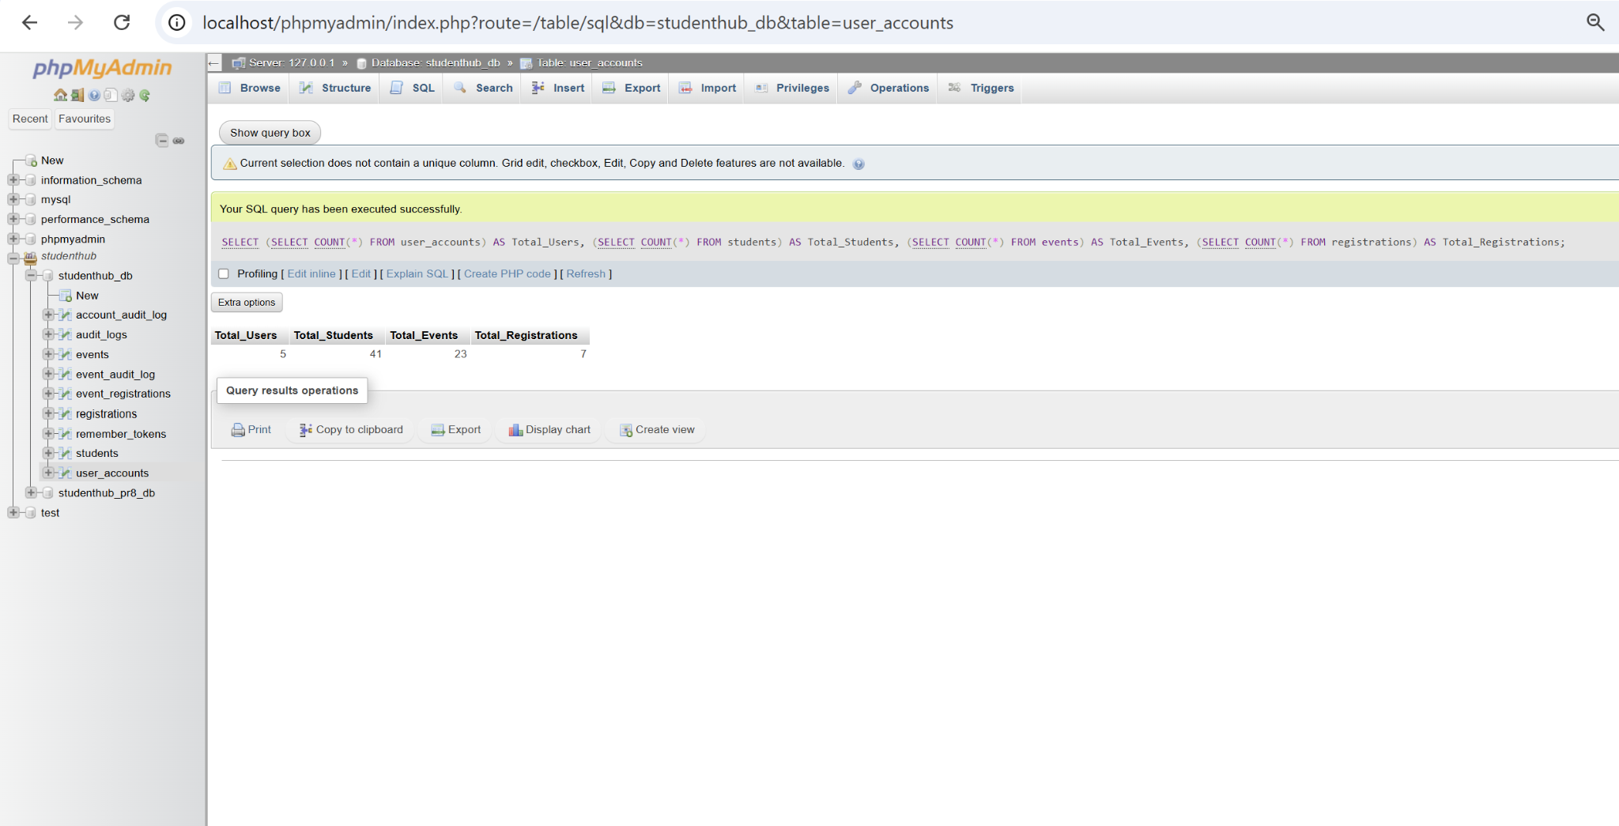
Figure 4: MySQL COUNT Results Match All Four Dashboard Totals

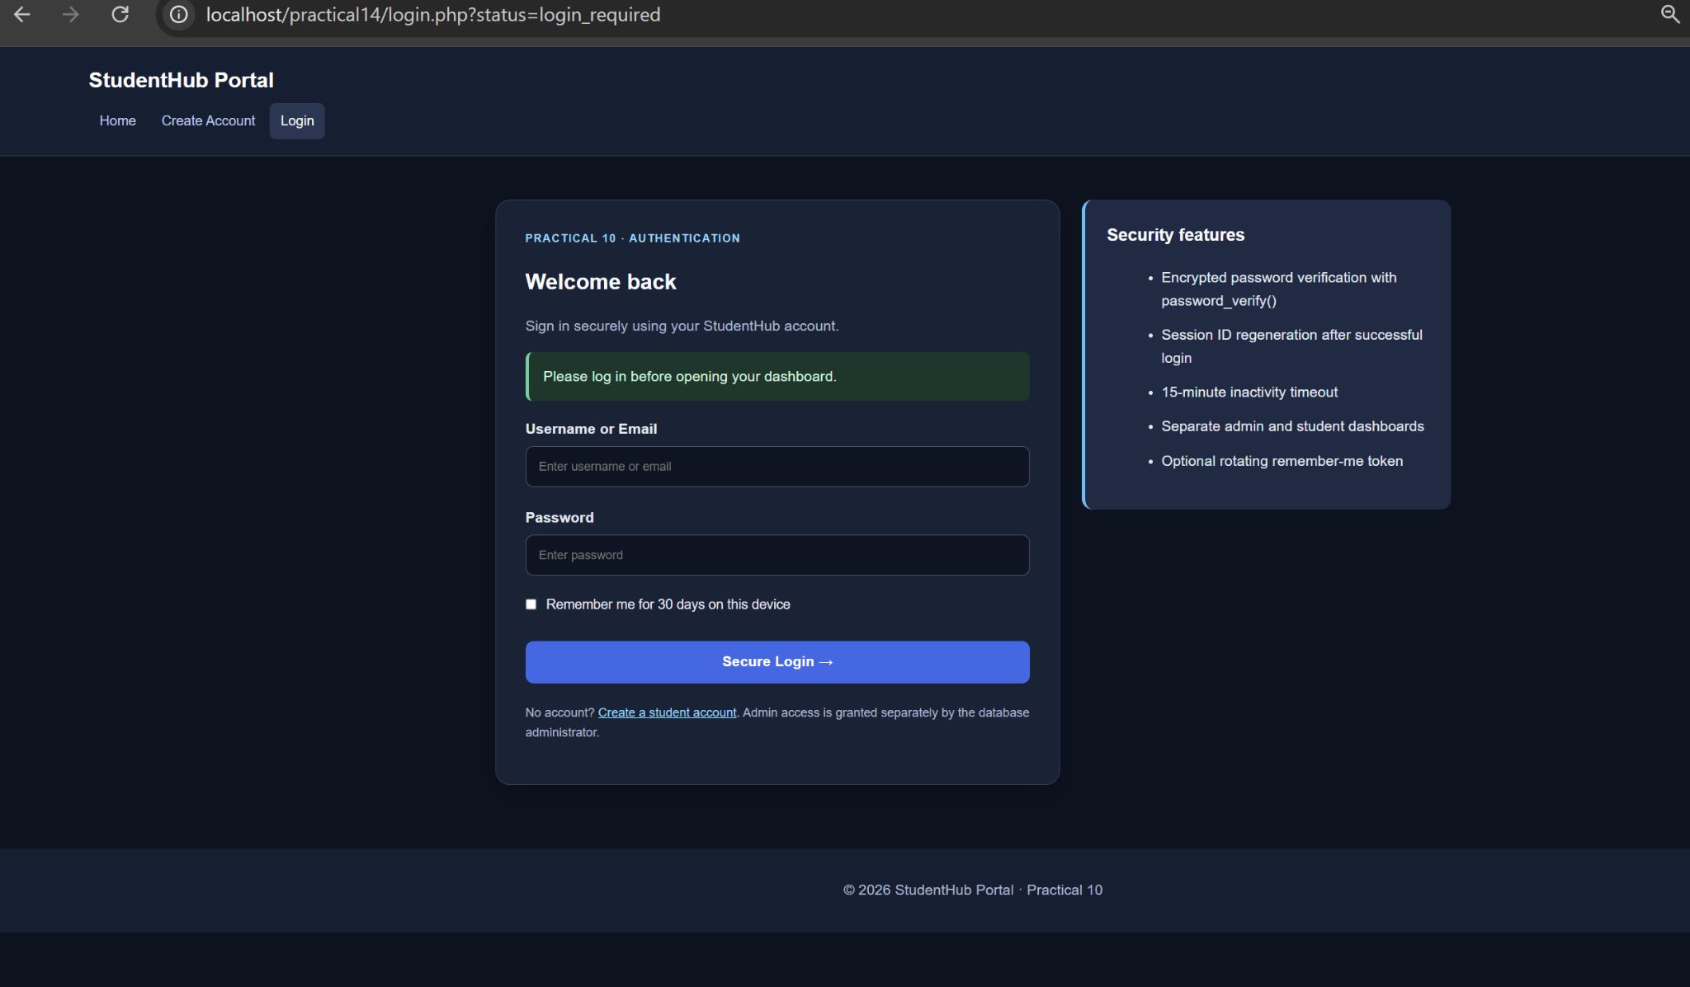
Figure 5: Unauthenticated Admin Request Redirected to Login
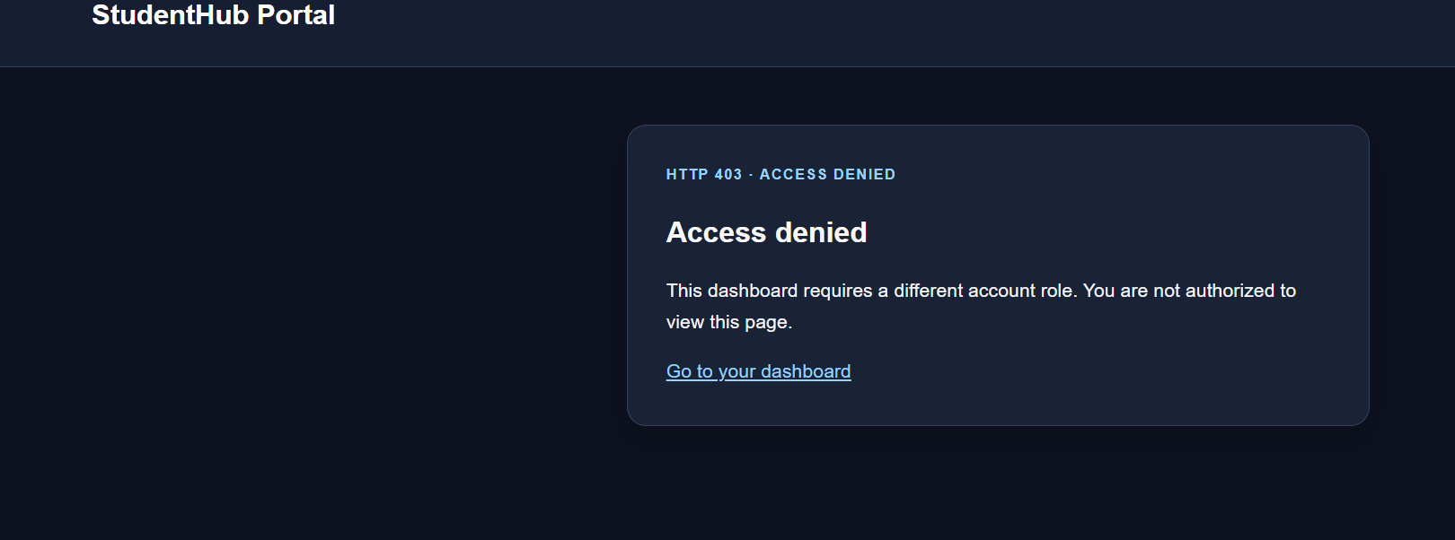
Figure 6: Student Role Denied Admin Dashboard Access (HTTP 403)

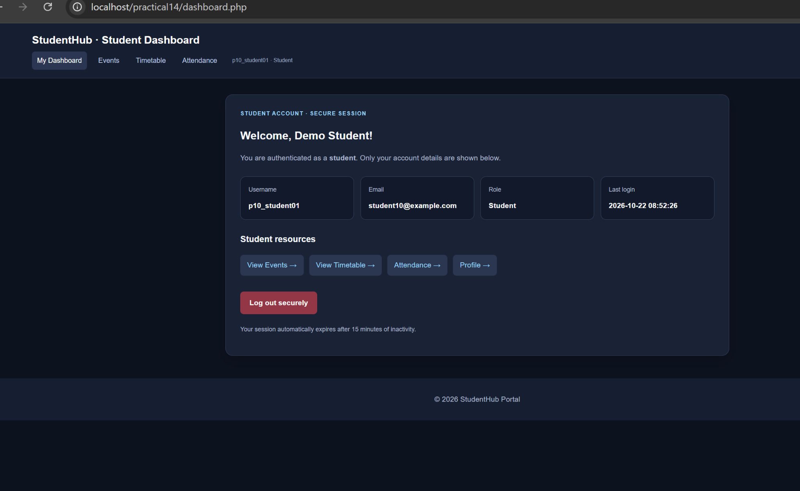
Figure 7: Student Dashboard Displays Role-Specific Navigation Menu
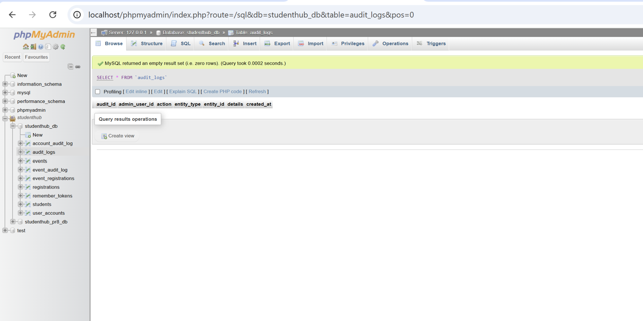
Figure 8: audit_logs Table Before Testing - No Actions Recorded

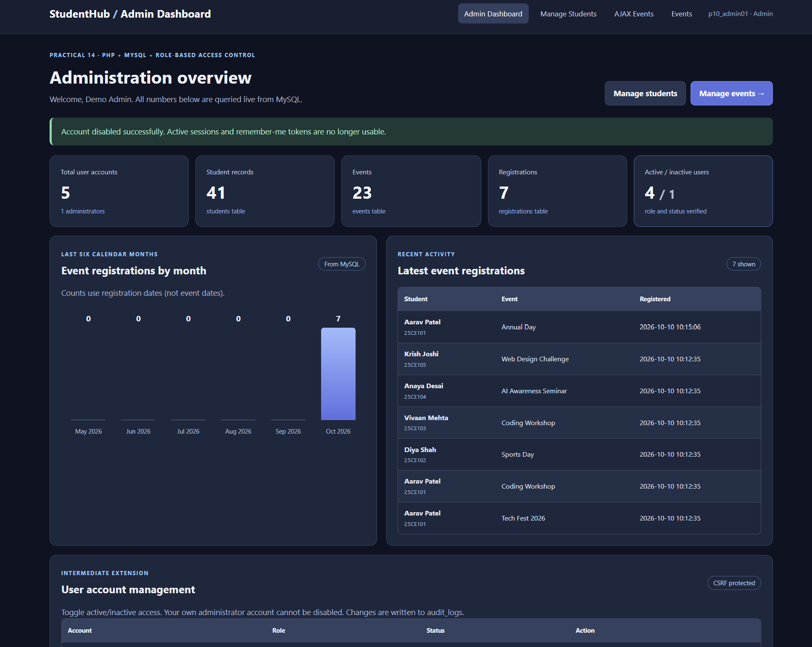
Figure 9: Test Account Disabled - Active and Inactive Counts Become 4 / 1
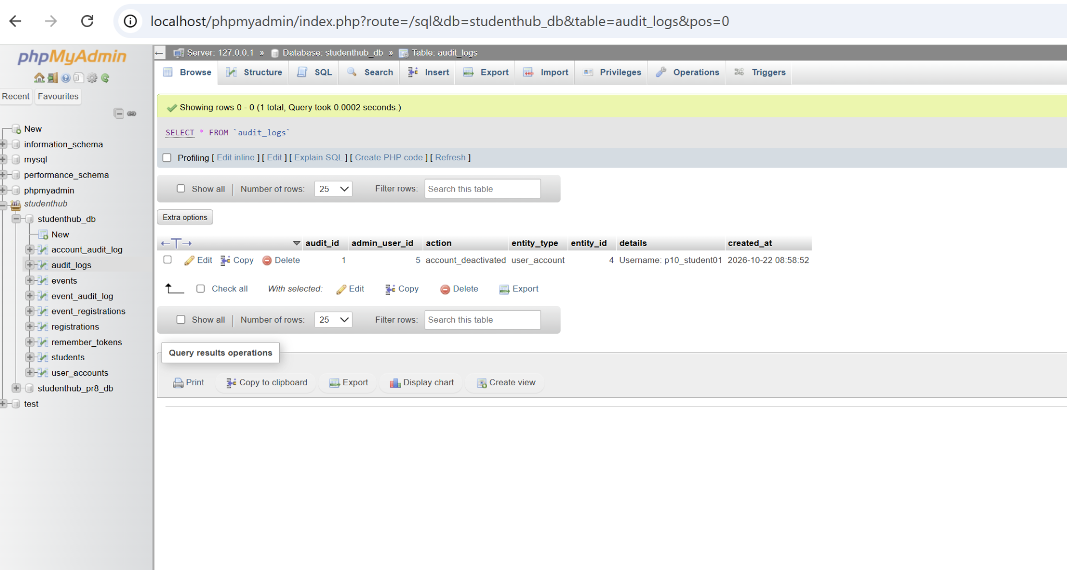
Figure 10: account_deactivated Entry Recorded in audit_logs

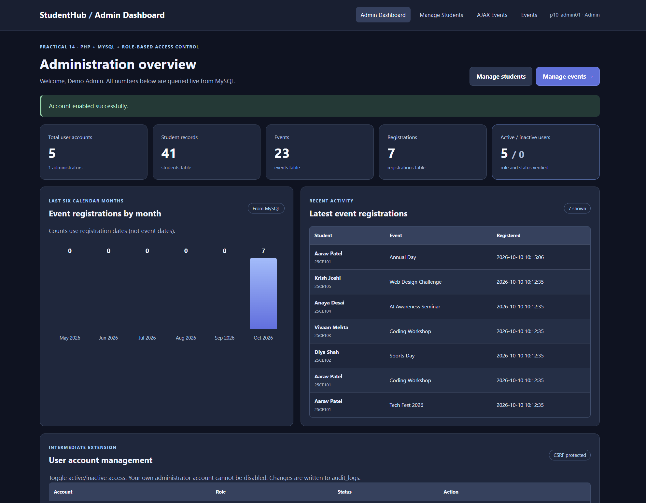
Figure 11: Student Account Reactivated - Counts Return to 5 / 0

A. GitHub Repository Link:
https://github.com/adrojatarang8-art/StudentHub

B. Challenges Faced:
• I resolved the initial “Database unavailable” message by importing practical14.sql into the existing studenthub_db.
• I compared the dashboard totals with independent MySQL COUNT queries to confirm that the numbers were not hard-coded.
• I verified admin protection using incognito browsing and then tested a separate student login for the HTTP 403 restriction.
• The audit_logs table started empty, so I performed a real account-status action to produce an auditable record.
• I reactivated the same account after testing to restore the initial 5 active and 0 inactive user counts.
C. Learning Outcome:-
I learned to implement a role-based PHP administrator dashboard that queries MySQL for statistics and latest registrations, displays a monthly analytics chart, restricts protected routes by session and role, renders different menus for administrators and students, and writes important administrative changes to an audit log. I also learned how to verify database values and access controls through browser and phpMyAdmin evidence.
Verification Note:
The deactivation audit entry was verified directly in phpMyAdmin. The reactivation success message and restored account counts were verified in the dashboard, but a separate activation audit entry was not captured. No GitHub commit/push, automated accessibility scan, or comprehensive production security audit is claimed here.
Faculty Remarks:

